Website Activity - Starter Task

Scenario
In this scenario we’re making a new website. For this example as we’re focussing on Git and GitHub, we won’t be programming, only using text documents for now to represent different code files.

Initial Set-up - Making the repository
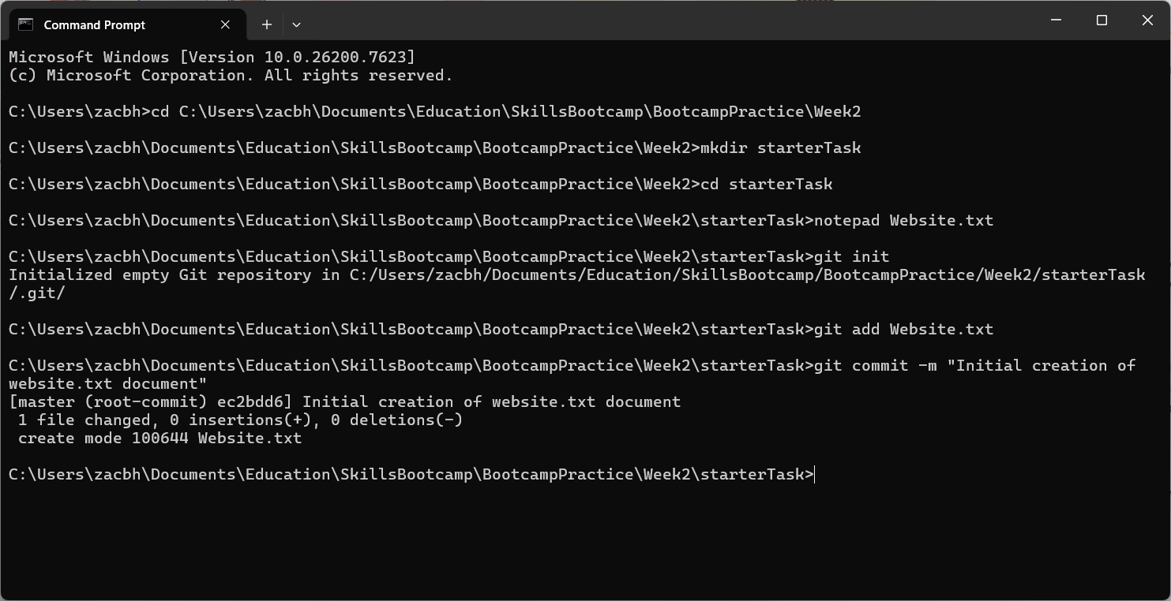

Adding text to the main file
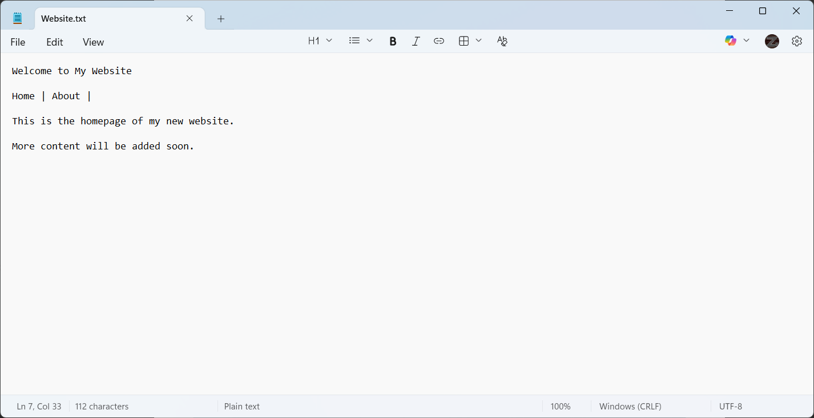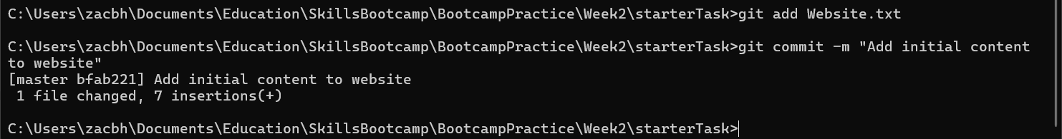

Git Log

Look at the Git log
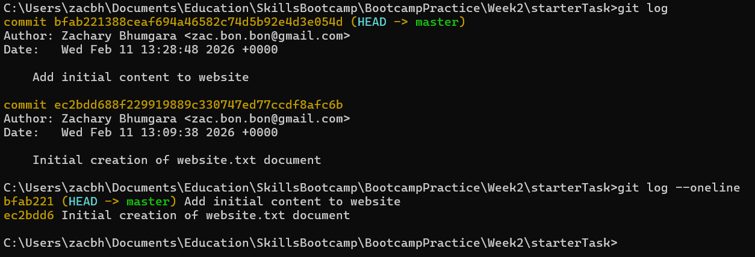

Flag: --oneline
The one line flag (--oneline) shows a list of commits as one line only, as the short commit hash, followed by the name, and any branch merges.

Git Show

Show HEAD
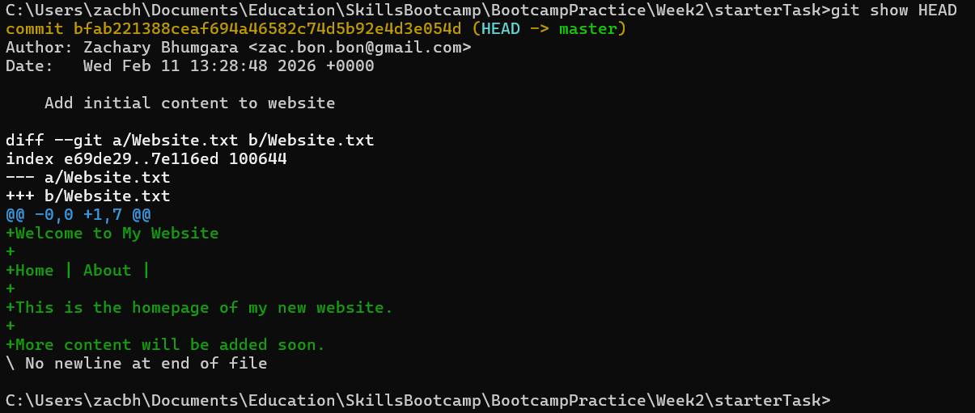

Adding the new contact form

Make a new branch for the contact form
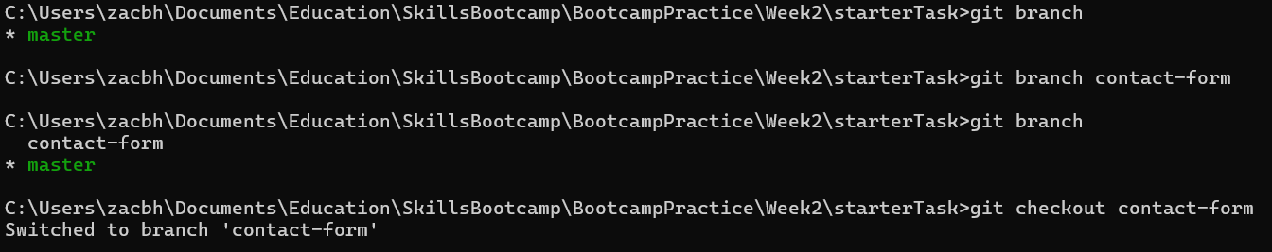

Checkout the new branch
Call git checkout contact-form to ensure that the new branch is switched to, like seen above.

Edit the website
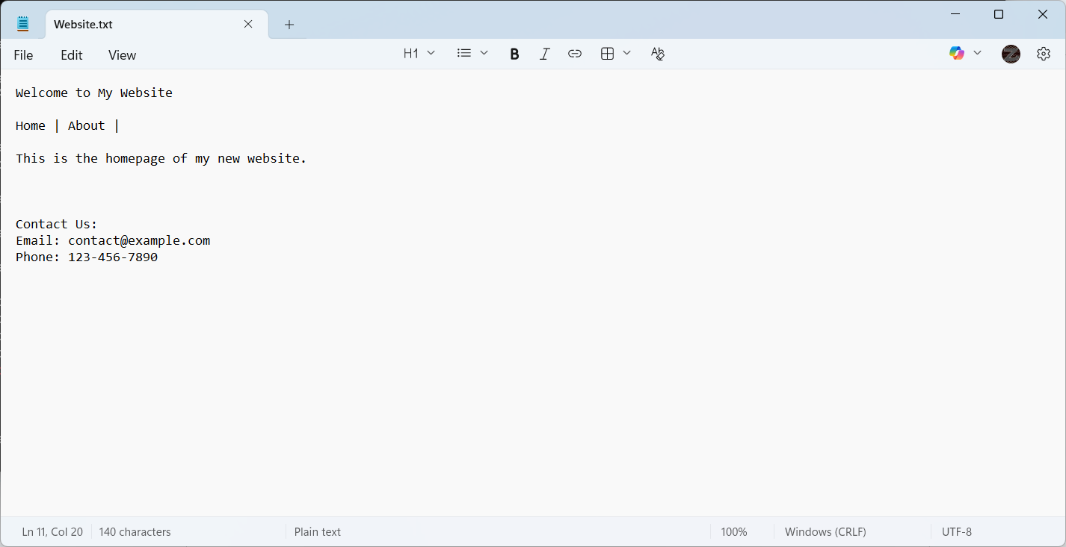

Commit the changes to the website to the new contact-form branch
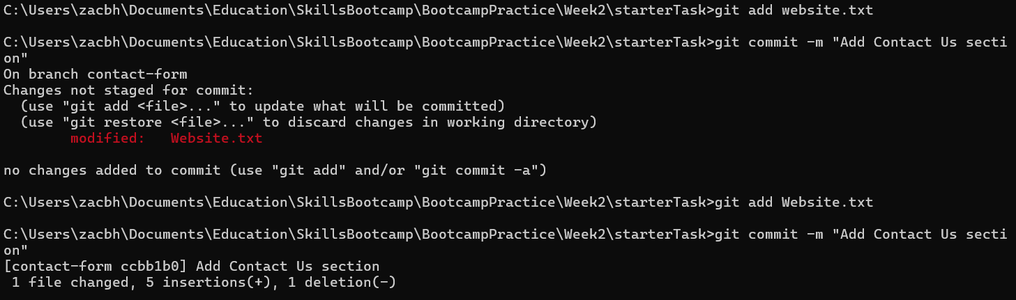
Ensure that you use the correct capitalisation and spelling, otherwise an error will be thrown.

Merge the contact-form branch to the master branch
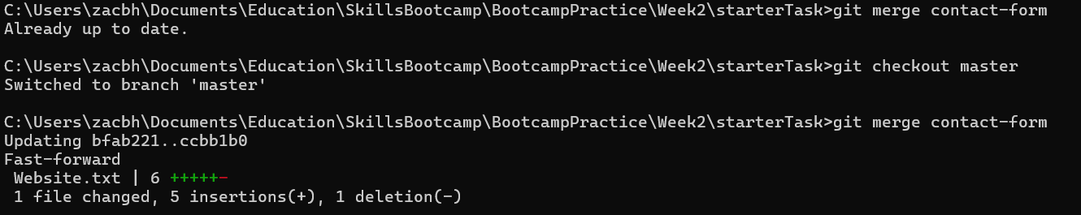
Ensure that you switch to the correct branch first, you can’t merge a branch into itself, and you don’t want to accidentally merge the wrong branch into the wrong one. So call git checkout for the branch you want to merge into, not the branch to want to merge into another.

Check the logs to ensure that the branches merged
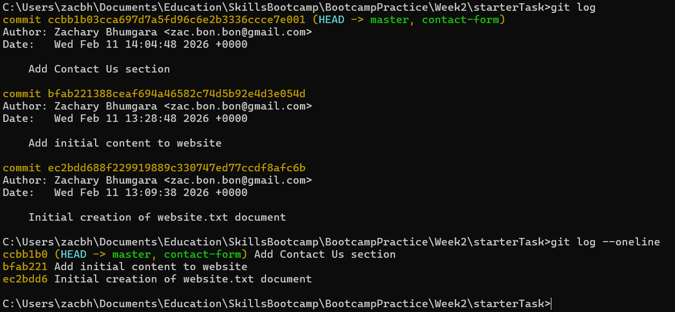
There is no merge commit here, this is because the git version fast-forwarded the branch merge.

Check the log graph
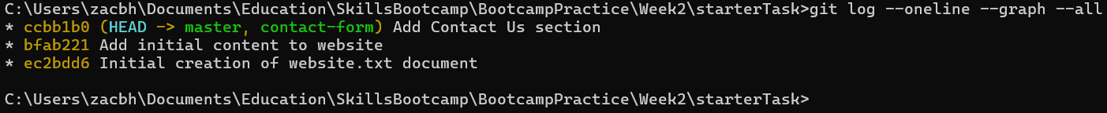
As the merge is fast-forwarded, there is no branch in the graph.

Adding the new pricing section

Create new branch for the pricing section

Make the appropriate changes to the text documents
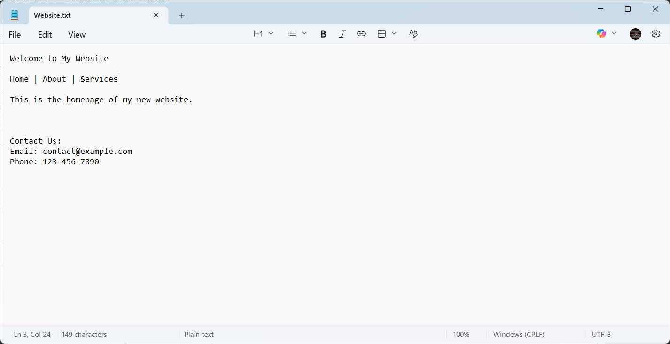
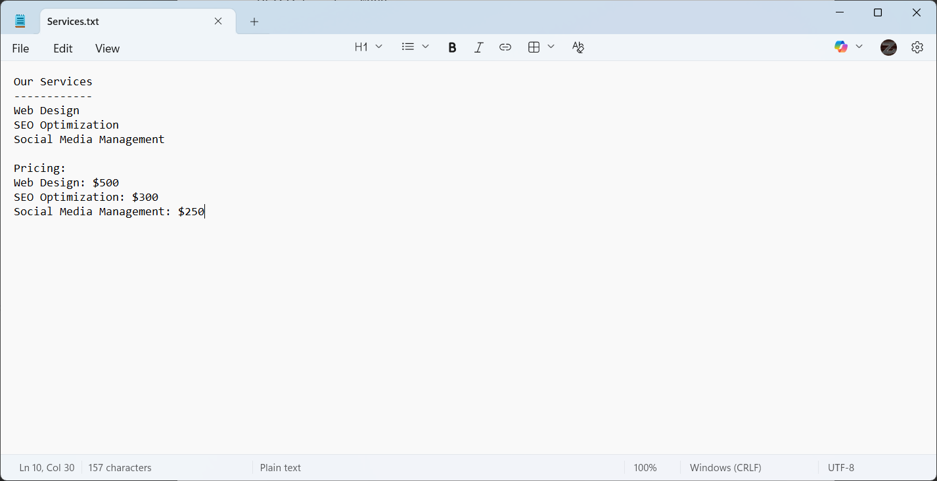

Add the files to the staging area, then commit the changes
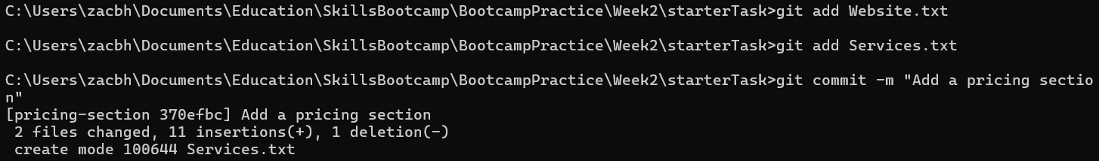

Checkout the master branch and merge in
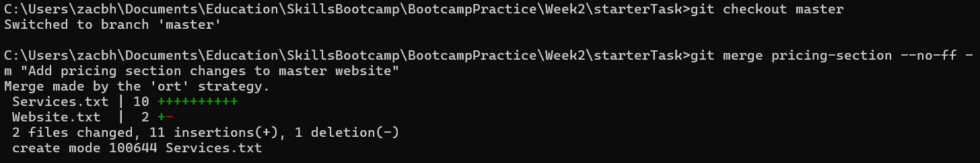
Use the --no-ff flag to avoid fast-forwarding, use the --m flag to assign a commit message to the merge.

Check the logs with a graph to ensure the pricing-section branch has been merged into the master branch
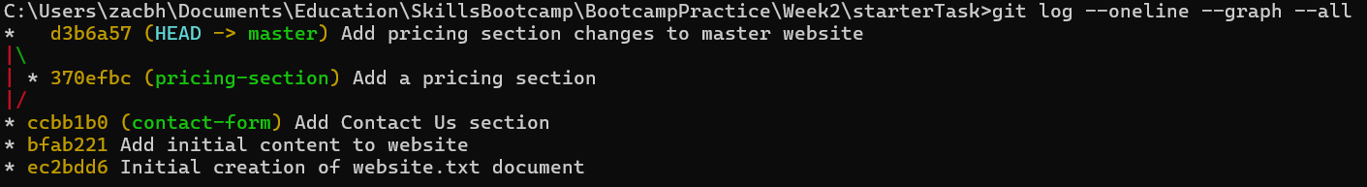
As we used the --no-ff flag, you can see the branching within the graph. While this is not necessary, it can be useful to look back upon the logs.

Using GitHub

Make a new remote repository on GitHub
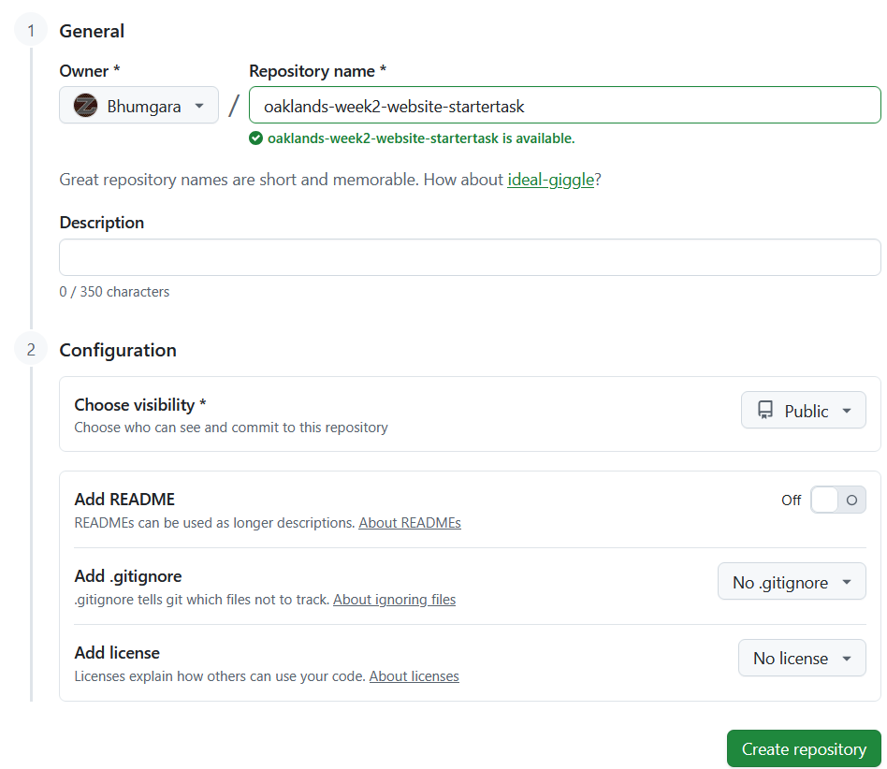
As I forgot to screenshot this stage earlier, it is slightly different, such that the repo name was oaklands-week2-website-task but is now oaklands-week2-website-startertask.
It can be either public or private, personally I changed this new repo (oaklands-week2-website-startertask) to private after taking the screenshot above.

Add the remote origin for a new GitHub
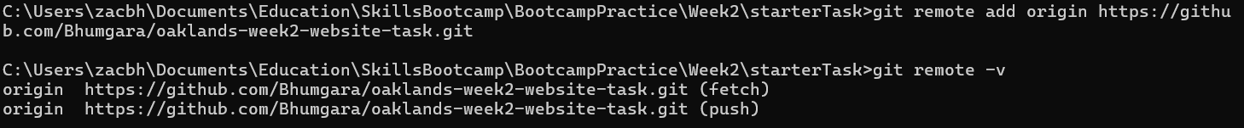
I added the oaklands-week2-website-task here as the remote origin, however we will change this to the oaklands-week2-website-startertask repo.

Change the origin for the remote repository, if you made an error and added the wrong remote repository.
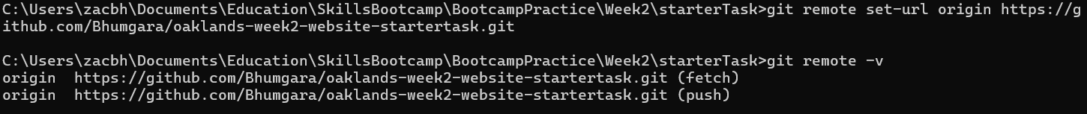
Now we’re back using the oaklands-week2-website-startertask repo as the chosen remote repository. Use git remote -v to double check the remote origin is updated.

Push the changes previously made for the website to a new branch

Make and switch to the new branch
The -b flag allows us to signify that the branch we’re checking out is a new branch to create.

Push the changes and commits stored locally to the new branch on remote
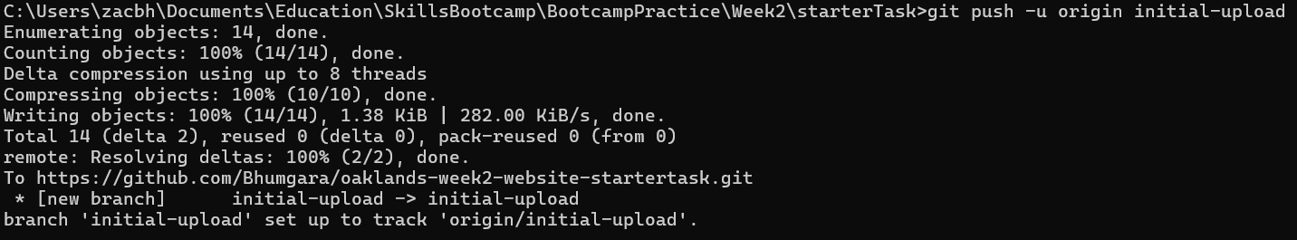
The -u flag allows us to set the upsteam (tracker) to the new branch. Where we’ll push all the changes we’ve made so far.

Make new main branch for remote

Make new main branch as an orphan

Remove any tracked files from the index
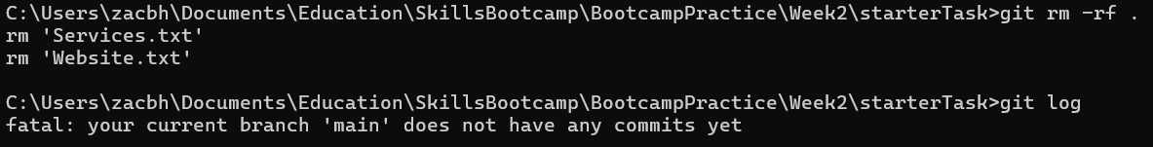

Create a new commit and push main to remote
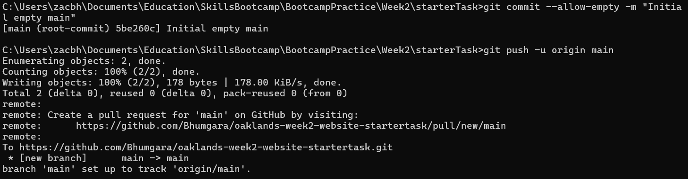

Use the GitHub UI to make main the new default branch
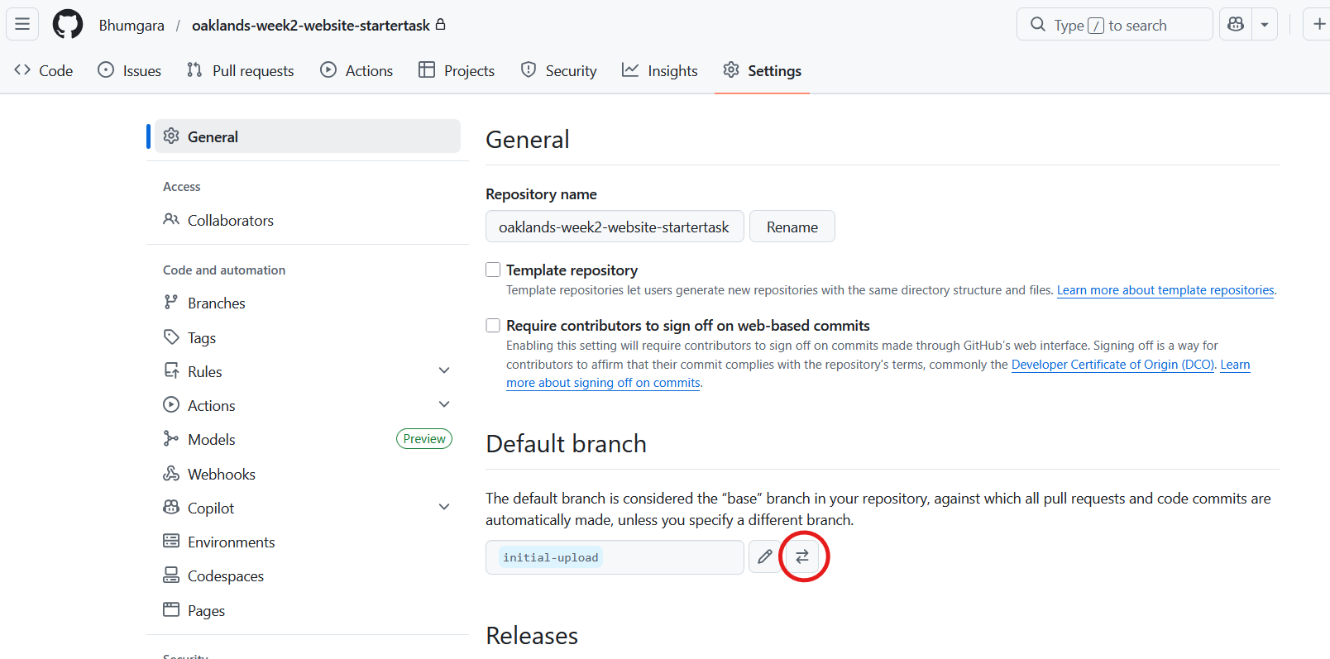
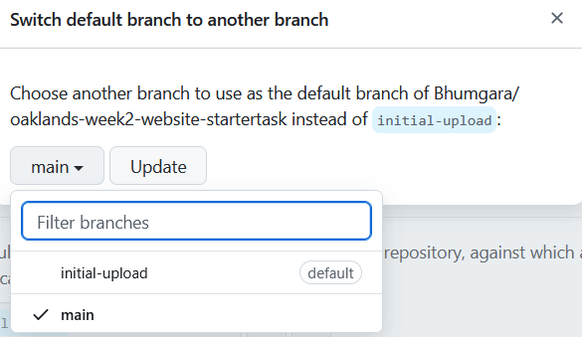

Create a pull request using the GitHub UI to compare changes between the initial-upload branch and master branch

Go to make a new pull request
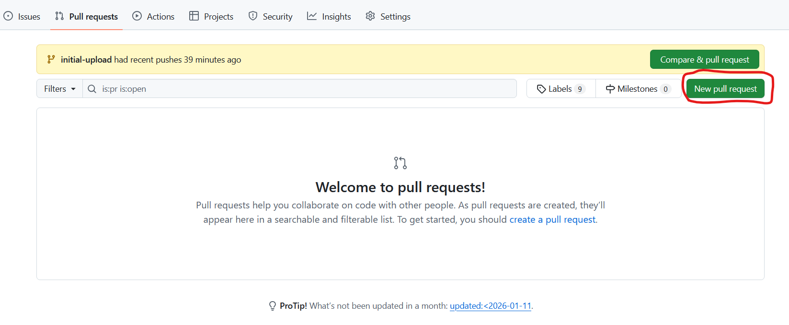

Find that there is nothing to compare
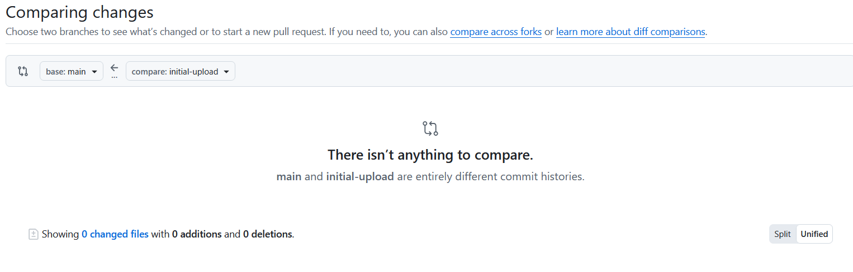

Check that the latest commit on both branches is different

Rebase the initial-upload branch from changes on main
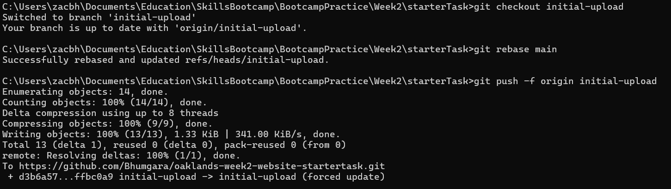

Make a new Pull Request
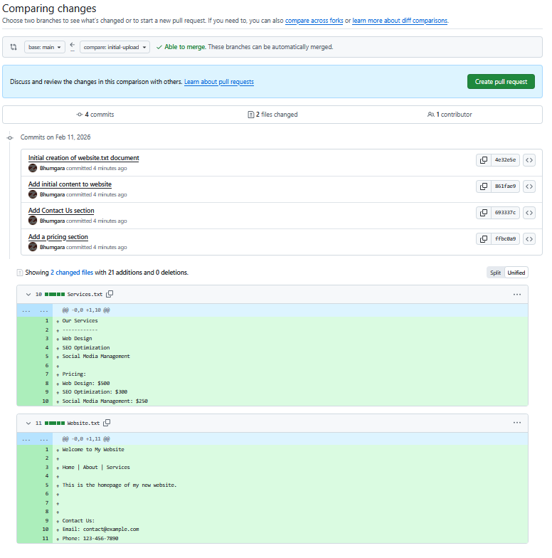
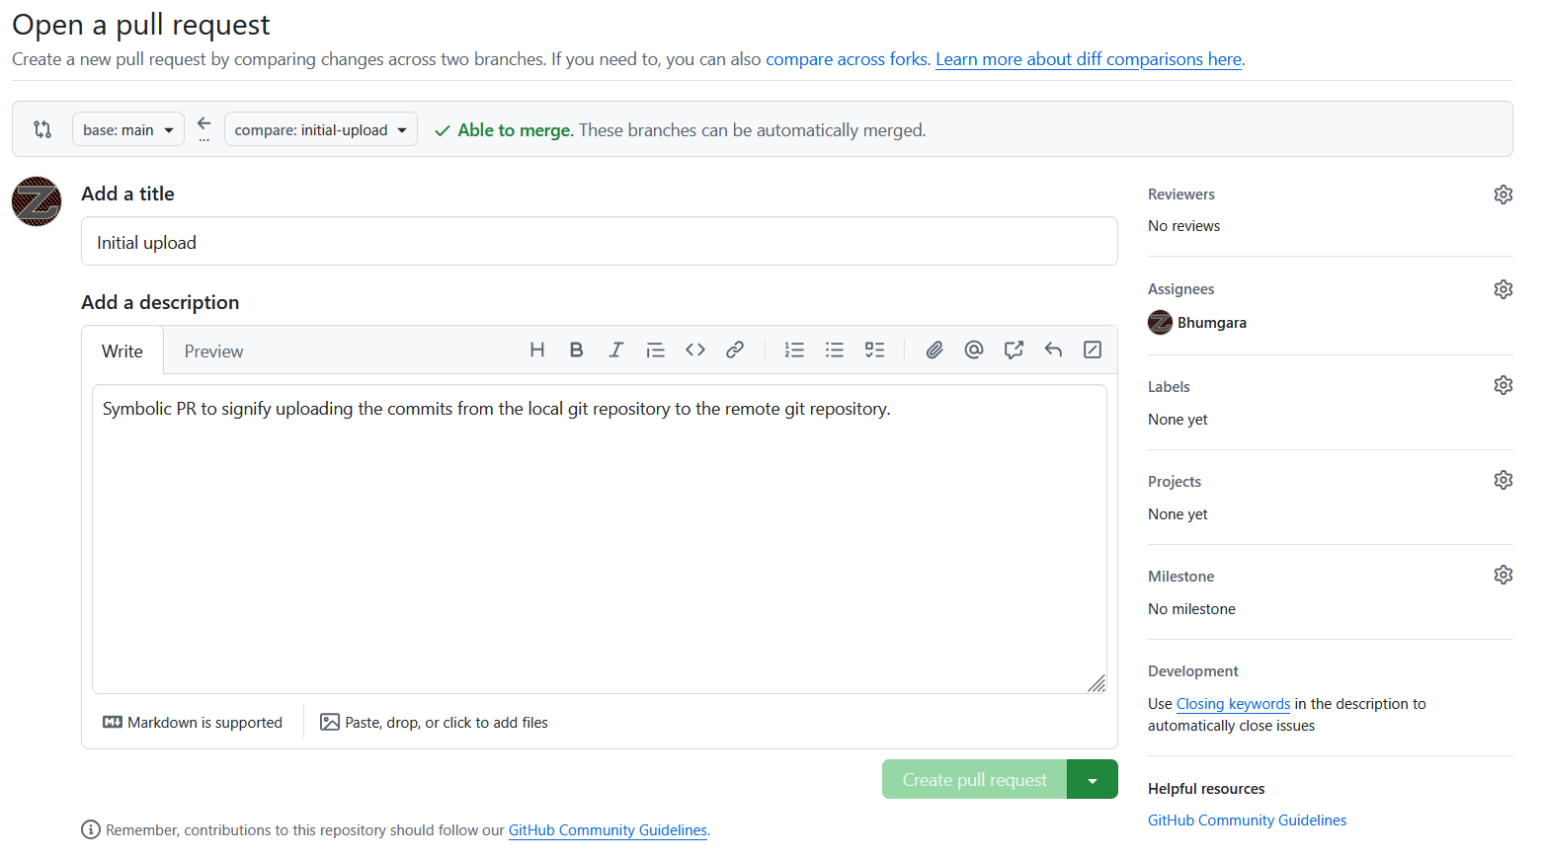

Check the Pull Request and approve
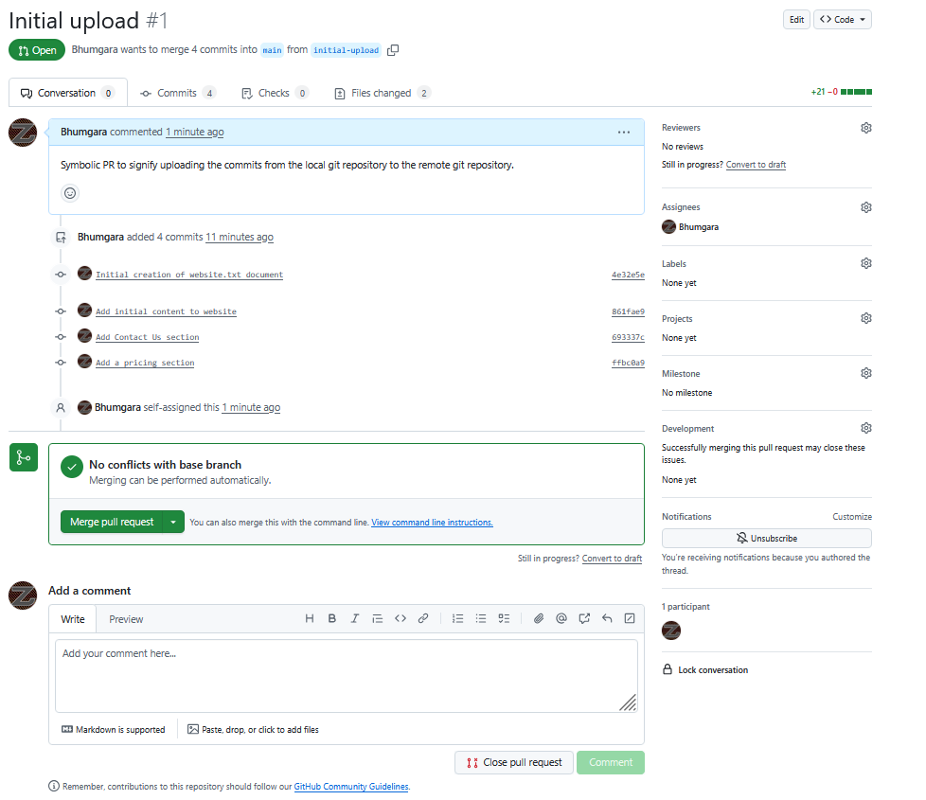
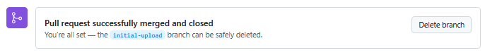

Adding the startertask repository as a submodule to given main skillsbootcamp repository

Identify the two repositories to work with
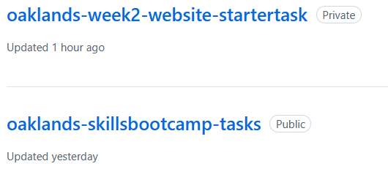
In this case I’m using the oaklands-skillsbootcamp-tasks repository as my “main skillsbootcamp” repository, and the oaklands-week2-website-startertask repo as the “startertask repository”.

Clone the main skillsbootcamp repository to a new local repository
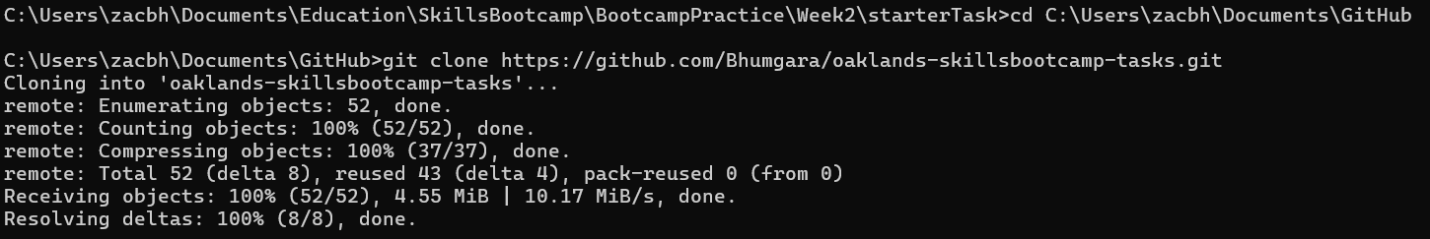

Move into the main skillsbootcamp repository

Checkout a new branch to make changes safely

Check which branch you’re currently on

Create and checkout a new branch
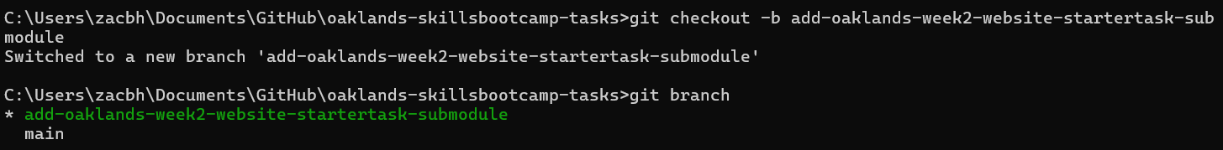

Make any new directories required to work within, if you wish to organise your work further
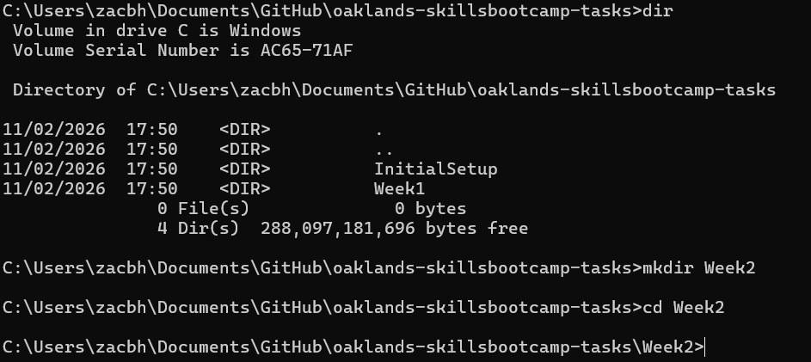
As can be seen, I’ve now moved into the new directory that I wish to add the content from this week to.

Add the startertask repository as a Git Submodule of the main skillsbootcamp repository
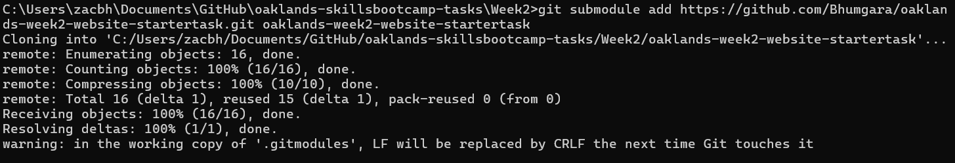

Check the current status of the Git staged and unstaged areas
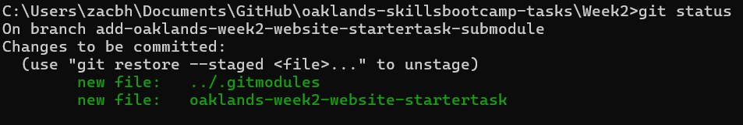

Add the new files to the staging area, if not already staged
My files were already automatically staged, by the submodule command, but it doesn’t hurt to double check.

After checking the status and ensuring the new submodule files are staged, commit your changes with an appropriate message
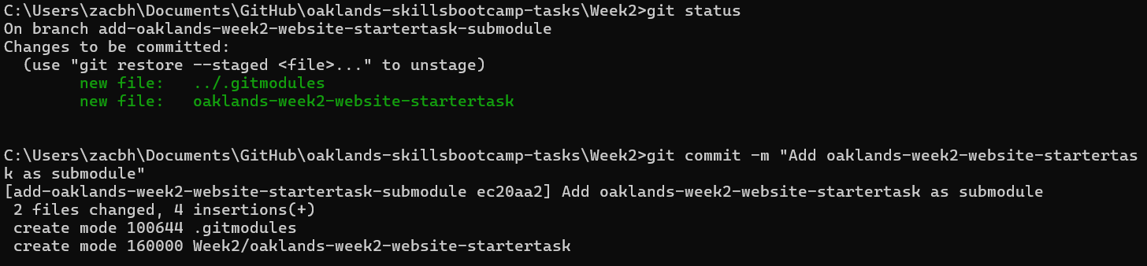

Push your changes to the branch on remote
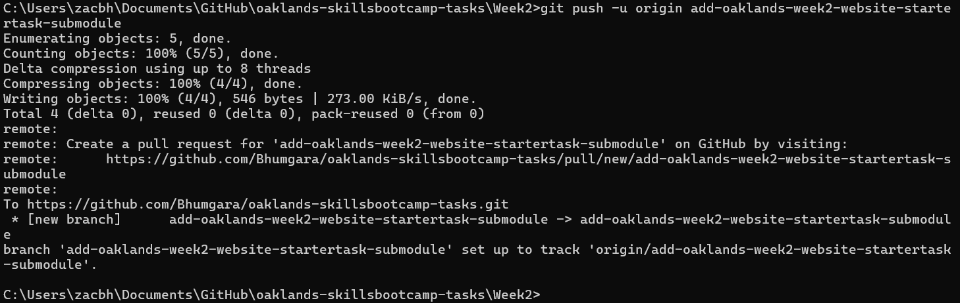

Create a PR to merge the branch into main
We now want to merge the branch that we made, add-oaklands-week2-website-startertask-submodule, into main. We can either do this as above in Make a new Pull Request, or alternatively if we install the GitHub CLI, we can create a new Pull Request through the Command Prompt (Cmd). As we’ve already covered how to make a PR in the GitHub UI, we’re going to learn how to achieve this through the Cmd.

Install the GitHub CLI
Run the command winget install GitHub.cli, you’ll get a similar output if you follow all the steps correctly.
Say Yes [Y] to the source agreements terms.
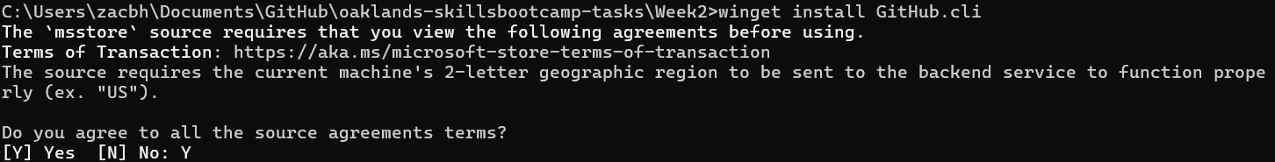
Then the installation should automatically proceed, if on a restricted user account, you may need administrator permissions.
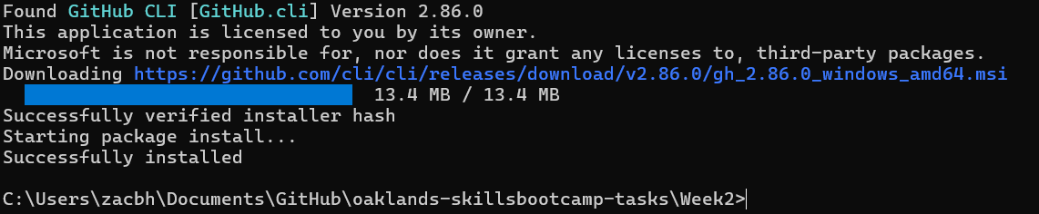

Check the version is correct to confirm installation, this will be whichever the latest version is if this document is outdated.

Authenticate GitHub
Use the command gh auth login to log in.
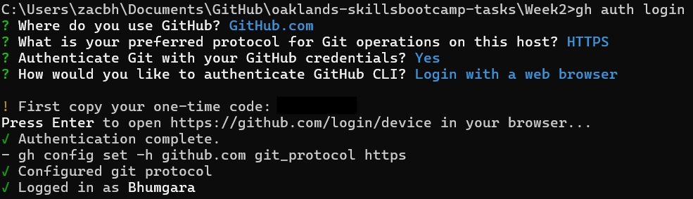

Check you’re in the branch that you want to create the PR from

Create the Pull Request
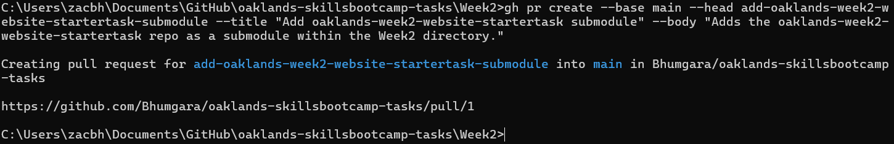
Remember to add the base, head, title and body as required. If you make a mistake, you can delete that PR and just make a new one, as seen below.

Deleting PR’s
Ok, I slightly lied before, you can’t delete PR’s, but you can close them.
To do this, just run the command in the screenshot below.
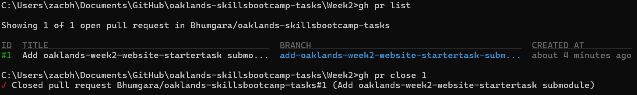
In the first command we check the list of PR’s to identify the PR we wish to close, then using the second command, we close it.

Merging a PR
After all the adjustments are made, and you have a PR you’re happy with, you can merge the PR from the CLI (command line interface) too.
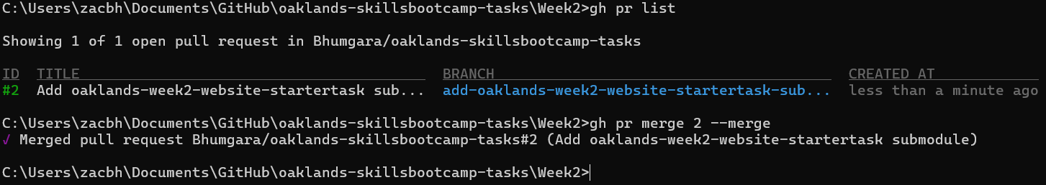
Once again, we check our PR list to ensure we have the correct PR, then, this time, we call the merge command, referencing the relevant PR by its given ID.

Check GitHub through it’s UI to confirm the PR has been merged
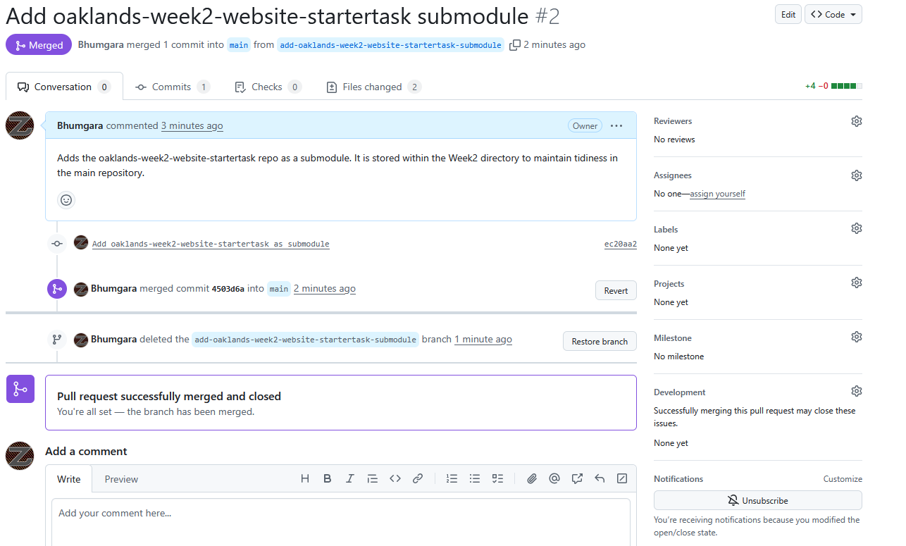
As seen here, the PR has been successfully merged, you can also see that I clicked the nifty little delete branch button already, this keeps the repository nice and tidy, once you’re done with a branch, you can delete it to keep the repo clean, I like to call it trimming, similar to “trimming” a bush to keep it neat.

